**Year 1 Quarter 4 IE&M 2020**  


**Change Management and IT**

Table of Contents

1. Introduction 3

1.1 Project Situation 3

1.2 Assignment 3

1.3 Plan of Approach 4

1.4 Project Team 5

2. Observations 5

3. Recommendations 6

3.1 Financial Picture 6

3.2 Customer Satisfaction 6

3.3 Occupancy Rate 7

4. Annexes 7

4.1 Performance Indicator Descriptions 7

4.1.1 Operating Result 7

4.1.2 Revenue 7

4.1.3 Cost 8

4.1.4 Customer Satisfaction 8

4.1.5 Number of Activity by Real Estate 8

4.1.6 Occupancy Rate 8

# 1. Introduction

### 1.1 Project Situation

Ons Huis, a housing corporation, is active in the south of the Netherlands. In 2005, Ons Huis was founded as a result of a partnership of two former housing companies. Following the merger, Ons Huis turned their focus to seeking the right strategic direction and creating an innovative strategy. This year, corporate strategy centres on the slogan "Let the Consumer choose". Ons Huis owns properties in 9 districts: Best, Eindhoven-Centrum, Eindhoven-Noord, Eindhoven-Oost, Eindhoven-West, Eindhoven-Zuid, Geldrop, Son en Breugel, and Veldhoven, respectively. Each of these districts has one or more of the five following residential properties: apartment, house, condo, small house and villa.

### 1.2 Assignment

The management team wants F108 to create a dashboard containing three mandatory performance indicators, namely Customer Satisfaction, Operating Result and Occupancy Rate of Residences, based on the data provided in the list of residences with basic information on real estate items, basic rental information, and basic maintenance and repair information. In line with this, the team will also plan a specific document to describe the roles of the project team to approach. The team also needs to provide the management with graphics to display each performance indicator.

### 1.3 Plan of Approach

The approach to the IT project chosen for this assignment is the Scrum approach. As specified by the approach, the Scrum approach will consist of three groups of people allocated to three separate positions, namely the Product Owner, the Scrum Master and the Scrum Team. The Product Owner must first be responsible for supplying the relevant information to the Scrum Master and Scrum Team in order to accomplish the stated goal. The Scrum Master will then break the job into small sprints for the Scrum team to focus on. The end outcome of the sprint will then be forwarded to the Product Owner for reviews, with more work being completed in upcoming sprints. This work-feedback cycle will occur until the desired end product has been achieved or the time frame has ended. The reason the Scrum approach was chosen is that the assignment can be split into smaller manageable sprints, the Scrum team is continuously updated during sessions, the Project Manager can have clear guidance on each iteration of the result, the Scrum Leader can easily lead the team and a useful tool can be created in a limited period.

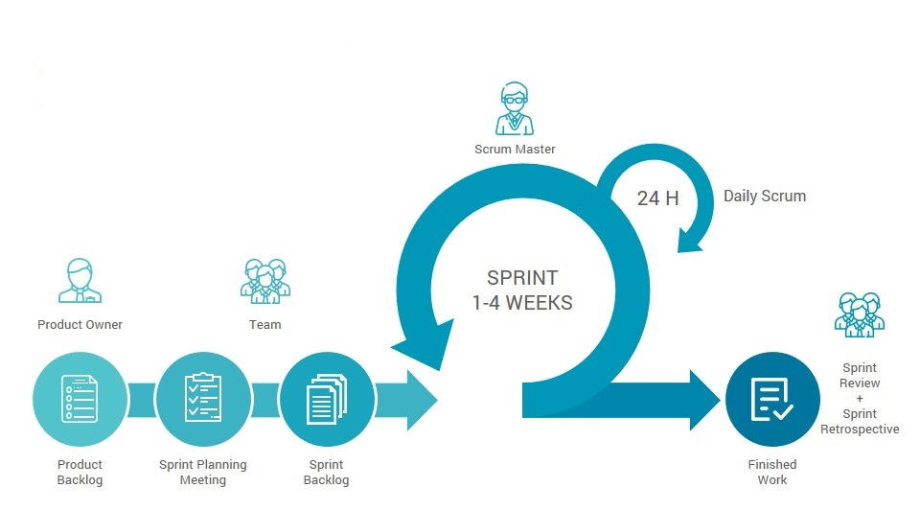

### 1.4 Project Team

1. Product Owner: The CFO, Arjan Beunen, will supply the team with details on emerging communities and facilities, while at the same time inspiring the strategy and vision of the housing corporation.
2. Scrum Master: Nararya Raeshad Yogantara will be Team F108's Scrum Master. He is in charge of leading the group by delegating tasks and setting deadlines, while also ensuring that the quality of work is at the very highest quality.
3. Scrum Team: The other F108 members will be part of the Scrum Team and their tasks will include data verification, implementation and supporting documents. No specific or official roles will be given to the team.

# 2. Observations

The following notable observations can be made from the dashboard:

The following significant findings can be made from the dashboard:

1. The Operating Result in 2018 earned the most (around 2.13 million euros). In contrast, 2016 earning the least at about 1.12 million euros. All these details have been obtained for the last 5 years.
2. For the past 5 years, Son En Breugel recorded disappointing financial performance with the lost of around 0.5 million euros, meanwhile Eindhoven-Oost stood out with the best operating result (more than 15.5 million euros).
3. For the past 5 years, the sum of cost has been decreasing, starting in 2015 costed about 0.31 million euros and 2019 costed about 0.29 million euros. The sum of revenue peaked in 2018 with 2.41 million euros and has the least in 2016 at about 1.45 million euros.
4. The top two districts that earn the most revenue is Eindhoven-West and especially Eindhoven-Oost (with a significant different as compared to others). The two districts at the bottom are Best and Veldhoven-Noord.
5. The average occupancy rate has generally risen by the end of 2017 and had peaked in 2018 with 82%. Geldrop and Eindhoven-Noord had the highest percentage rate with 80.56% and 78.24%, respectively. Eindhoven-Centrum has had the lowest average percentage rate of 61.83% over the last 5 years.
6. Customer satisfaction by district percentage rate peaked in Veldhoven-West and Eindhoven-Centrum and the lowest is in Eindhoven-Noord with 28.21%.
7. The annual customer satisfaction percentage rate peaked in 2015 by 56.41%, and is the lowest in 2016 by 45.45% in the past 5 years.

# 3. Recommendations

### 3.1 Financial Picture

In the past 5 years, the company has achieved an increasing trend from year 2015 to 2019 although the numbers fluctuate but the overall revenue increased from year 2015 to 2019 for 197,630 Euros. However, the peak of the revenue itself occurred in 2018 which has a number of 2,408,375 Euros. Based on the total revenue and cost sorted by year, the company is improving and developing for the long run in the financial aspect, the increasing amount of sales revenue and also the decreasing amount of the costs. However, if the numbers are sorted by district, then there are some districts that have no earnings but with costs that are making the overall profit reduced. Both the districts are Best and Son en Breugel, the costs from both of them are more than Veldhoven-Noord and Veldhoven-West although Veldhoven districts produce more money than Best and Son en Breugel. Eindhoven-Oost and Eindhoven-West are the districts that produce the most revenue than the others but with also higher amounts of costs. F108 recommends that there should be income for the district of Best and Son en Breugel, also it is recommended to invest more in Eindhoven-Oost and Eindhoven-West because it has the highest amount of revenue.

### Customer Satisfaction

All the expenses are taken into account to determine customer satisfaction. The company experienced a fluctuating pattern in the satisfaction of the customers from 2015 to 2019. Basically, this figure is based on the amount of repair, maintenance, and renovation. The more activity costs, the less satisfaction the customer receives.

The costs are also having a fluctuating trend and it correlates to the customer satisfaction number. The number of activities including the repair, maintenance, and renovation are also taken into account. 2015 was the peak of customer satisfaction in the last 5 years and it is gradually decreasing because of the number of costs and activity that are increasing. By looking at the customer satisfaction graph by district, it is obvious that Eindhoven-Noord and Veldhoven-Noord are having the lowest numbers between all of the districts while Eindhoven-Centrum and Veldhoven-West are having the highest customer satisfaction. We suggest that the company bring up new policies that can satisfy the customers.

### Occupancy Rate

The company wants to improve sustained profit in the long run, that is when taking into consideration the occupancy rate. The occupancy rate of the company is growing year by year, which is a good sight, although it had the peak in 2018 and it decreases in 2019. But the overall growth is really good for the company. We want to help the company to build better occupancy rates in each district. Even though small houses may have the highest occupancy rate, the other properties also have similar numbers in the figure with only a margin of 5%. More attention should therefore be paid to those types which will generate more profit. We suggest that the company conduct more marketing schemes for all of the properties in every district, especially the types that have less rate than the others, such as advertising, promotions, and so on. This will contribute to having the optimization for the profit.

# 

# 

# 

# 

# 4. Annexes

## 4.1 Performance Indicator Descriptions

### 4.1.1 Operating Result

The operating result is calculated as rental income revenue minus the maintenance, repair and renovation costs. This performance indicator is implemented by creating the table and visualizations for the last 5 years and by each district in terms of the sum of real rent and sum of activity. These charts are compared with showing the company's operating result.

### 4.1.2 Revenue

To evaluate the company's annual sales and compare each district's profit and loss, and categorize by item. This performance indicator is implemented by creating a table and the visualization for the last 5 years regarding the sum of the real rent and the sum of the activity cost.

### 4.1.3 Cost

Analyzing through activity from the past 5 years that cost more money in each district.

### 4.1.4 Customer Satisfaction

Measures customer satisfaction by the lowest number of repairs per district. Customer satisfaction is calculated using 100% minus pivot table percentage of data. This performance indicator is enforced annually by creating a table and the visualization which consists of the count of the activities' real estate (maintenance, repair, and costs).

### 4.1.5 Number of Activity by Real Estate

Analyze which activity occurs most that requires more maintenance, repair, and renovation of real estate items. This performance indicator is applied by using the relationship function to look up the maintenance, repair, and renovation worksheet's real estate number and the worksheet on residence details to find the exact district. A table and the visualization is created in respect of each real estate item's activity count.

### 4.1.6 Occupancy Rate

Measures are visualized in percentage by using real rent divided by planned rent. The idea is to compare which district has the most occupied real estate item and which real estate item has the most occupancy rate of the last five years. Implementing this performance indicator is established by using calculations in the table and visualizing it to show the annual average occupancy rate, by each district, and by each property element.